**TASK-2**

Provide the following information for each combination of department_desc and type_desc:

turnover for clearance sales (cle_sls_dlr) for the years 1999, 2000 and 2001 as well as the increase (in percent) from one year to the following year.

Your result document must include:

* A screenshot of the complete result table
* the SQL statement or the sequence of SQL statements that you used to derive the result table
* a short explanation on the idea behind the queries

*A screenshot of the complete result table:*

For Year 1999:

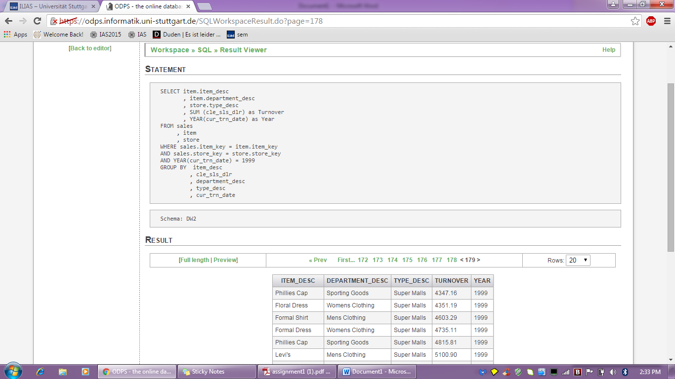

For Year 2000:

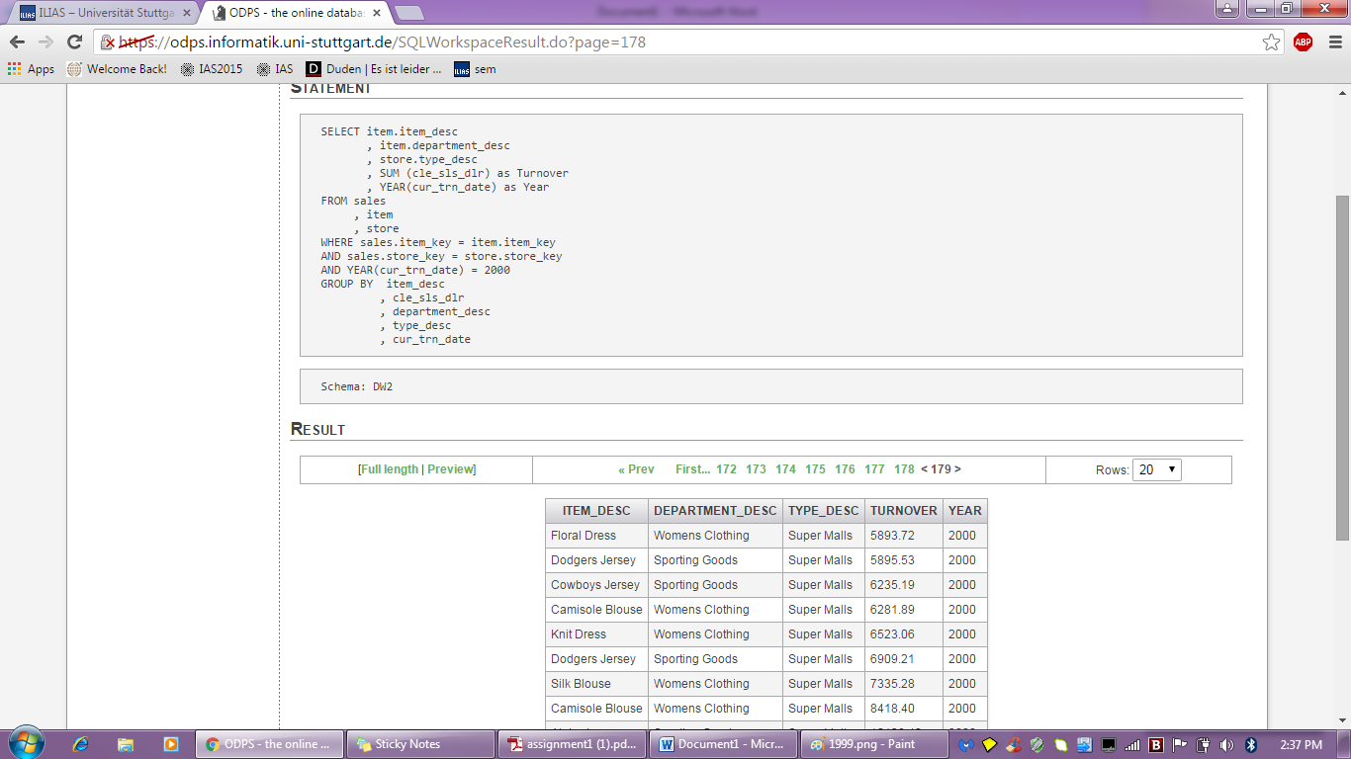

For Year 2001:

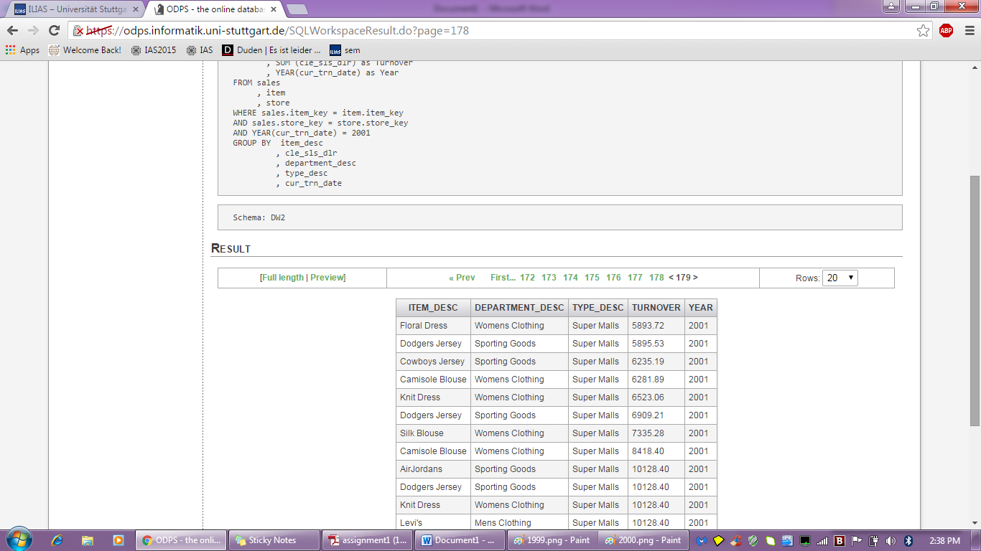

*The SQL statement or the sequence of SQL statements that you used to derive the result table:*

For Year-1999:

SELECT item.item_desc

, item.department_desc

, store.type_desc

, SUM (cle_sls_dlr) as Turnover

, YEAR(cur_trn_date) as Year

FROM sales

, item

, store

WHERE sales.item_key = item.item_key

AND sales.store_key = store.store_key

AND YEAR(cur_trn_date) = 1999

GROUP BY item_desc

, cle_sls_dlr

, department_desc

, type_desc

, cur_trn_date

For Year 2000:

SELECT item.item_desc

, item.department_desc

, store.type_desc

, SUM (cle_sls_dlr) as Turnover

, YEAR(cur_trn_date) as Year

FROM sales

, item

, store

WHERE sales.item_key = item.item_key

AND sales.store_key = store.store_key

AND YEAR(cur_trn_date) = 2000

GROUP BY item_desc

, cle_sls_dlr

, department_desc

, type_desc

, cur_trn_date

For Year 2001:

SELECT item.item_desc

, item.department_desc

, store.type_desc

, SUM (cle_sls_dlr) as Turnover

, YEAR(cur_trn_date) as Year

FROM sales

, item

, store

WHERE sales.item_key = item.item_key

AND sales.store_key = store.store_key

AND YEAR(cur_trn_date) = 2001

GROUP BY item_desc

, cle_sls_dlr

, department_desc

, type_desc

, cur_trn_date

*A short explanation on the idea behind the queries:*

SELECT item.item_desc

, item.department_desc

, store.type_desc

, SUM (cle_sls_dlr) as Turnover

, YEAR(cur_trn_date) as Year

In this line the Description about the item, department, type, turnover for clearance sales and the year for which the data is needed is selected.

FROM sales

, item

, store

The data are taken from the Sales, Item and the Store tables.

WHERE sales.item_key = item.item_key

AND sales.store_key = store.store_key

AND YEAR(cur_trn_date) = 2000

The tables are joined using the primary keys and the turnover for the year required is mentioned.

GROUP BY item_desc

, cle_sls_dlr

, department_desc

, type_desc

, cur_trn_date

Group By is used to group the result set and the columns used in the SELECT statement are used.

Sorry for percentage change I could not get. Some error is coming.

